Apple Developer Set-Up

**Apple Developer Overview**  
  
Apple Developer offers both free and paid programs. Free programs include a basic Apple Developer account and the Safari Developer Program, while paid plans include the iOS Developer Program and the Mac Developer Program. Paid memberships are for one year, and are renewable at the same price as originally purchased. Alternate versions of these programs targeted towards universities and enterprises are also available.

**Benefits of Membership**

* **Support from Apple engineers** — Apple Developer Program members are eligible to receive help such as [technical support](http://en.wikipedia.org/wiki/Technical_support) and code support, directly from Apple engineers in their products.
* **Apple Developer Library** — The Apple Developer reference library provides developer news, technology releases, and technical information. As well, it provides Apple-authored technical documentation, a wide range of [Software Development Kits](http://en.wikipedia.org/wiki/Software_Development_Kits), tools, and sample code.
* **Access to pre-release software** — Another notable feature of the Apple Developer Program is the ability to receive pre-release software, most importantly pre-release versions of Apple's own operating system, as well as other Apple software. Apple products are regularly seeded whenever a build occurs.
* **Eligibility to attend the**[**World Wide Developers Conference**](http://en.wikipedia.org/wiki/World_Wide_Developers_Conference) — With an Apple Developer Program membership comes the eligibility to attend the WWDC, one of the premier Mac conferences held throughout the year. In the past, the WWDC has been the venue for the introduction of [Mac OS X v10.3](http://en.wikipedia.org/wiki/Mac_OS_X_v10.3), [Mac OS X v10.4](http://en.wikipedia.org/wiki/Mac_OS_X_v10.4), and [Mac OS X v10.5](http://en.wikipedia.org/wiki/Mac_OS_X_v10.5), as well as the introduction for the [Power Mac G5](http://en.wikipedia.org/wiki/Power_Mac_G5) - and its successor, the [Mac Pro](http://en.wikipedia.org/wiki/Mac_Pro).
* **Invitations to exclusive workshops** — Apple Developers receive invitations to exclusive workshops, and conferences about the latest technologies. Generally, the workshop is a demonstration of the latest Apple technology done by an Apple engineer.
* [**iPhone SDK**](http://en.wikipedia.org/wiki/IPhone_SDK) — Apple Developers can download the iPhone SDK in order to write applications targeting [iOS](http://en.wikipedia.org/wiki/IOS_%28Apple%29). The iPhone SDK is available in all Apple Developer accounts, including free memberships.
* **Compatibility testing** — The Apple Developer Program provides compatibility testing for new Applications. The compatibility testing, located in [Cupertino](http://en.wikipedia.org/wiki/Cupertino), [California](http://en.wikipedia.org/wiki/California), [Tokyo](http://en.wikipedia.org/wiki/Tokyo), [Japan](http://en.wikipedia.org/wiki/Japan), and [Beijing](http://en.wikipedia.org/wiki/Beijing), [China](http://en.wikipedia.org/wiki/China). At the Cupertino campus alone, there are three separate labs which collectively have hundreds of Mac configurations, with several different third party peripherals.
* **Listing on the App Store** — Apple Developer Program members are able to submit their applications to the [Mac](http://en.wikipedia.org/wiki/Mac_OS_X) or [iOS](http://en.wikipedia.org/wiki/IOS_%28Apple%29) [App Store](http://en.wikipedia.org/wiki/App_Store), where they can either publish their application for free, or sell their product to end-users.

**Registration**

The Apple Developer registration process is extremely simple. Below is a step-by-step guide. If you run into any issues, we recommend contacting Apple support directly at **1-800-633-2152**.  
  
  
**1**. First, register for the [iOS Developer program](https://developer.apple.com/programs/ios/) by clicking the Enrol Now link.

<https://developer.apple.com/programs/ios/>  
  
**2**. On the next screen, read up on the program, then click Continue at the bottom to proceed.  
 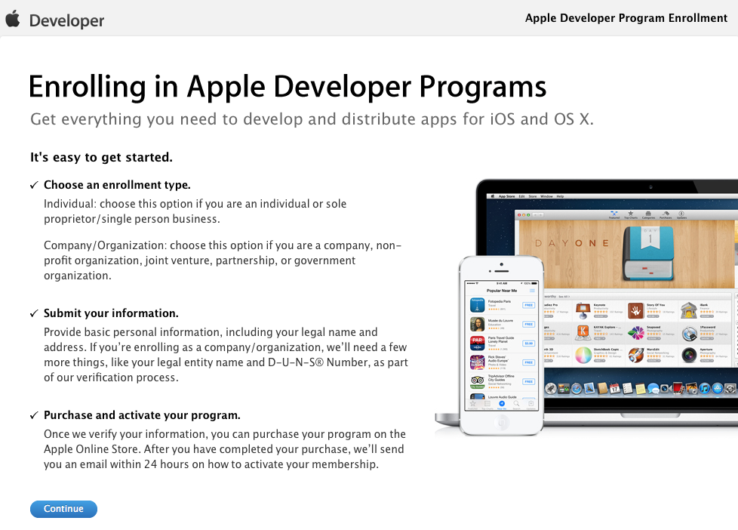

**3.** Next, you'll be prompted to sign in or create an Apple ID. You can use your existing ID (most people have one set-up for their iTunes account/iPhone) or register a new one—entirely up to you.

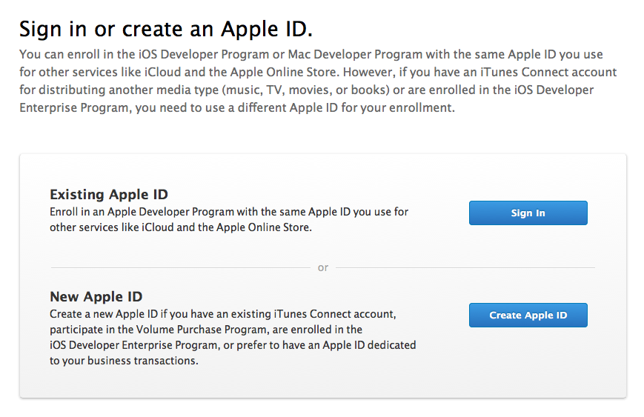

**Note:** If you opt to create a new Apple ID, the following steps will vary slightly, as you'll need to input billing info and personal details.  
  
**4.** On the next screen, you'll be asked, "Are you enrolling as an individual or organization?" Select Individual for now. The process is quicker than business/organization registration.  
  
**5.** If you're using an existing Apple ID, you'll be prompted to log in.  
  
**6.** Agree to the agreement to proceed to the next step.  
  
**7**. Complete the "Tell us about yourself" section. Under "What are you developing," select iOS: Apps (App Store). You can check the box for Android under the "What other platforms do you develop for?" section as well.

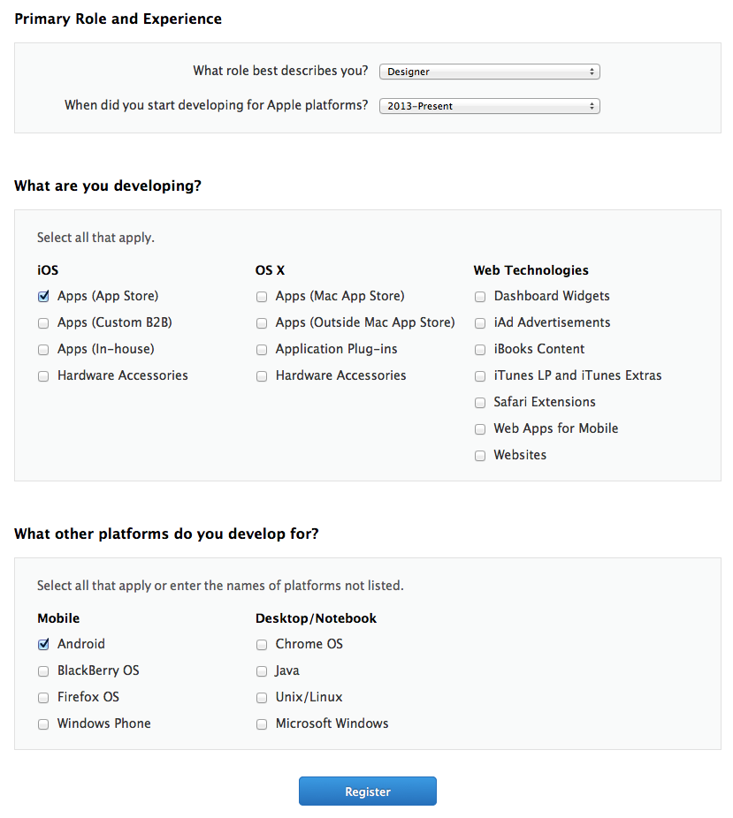

**8.** Click Register, and you'll be taken to a contact information screen. Fill out your billing address and continue.

**9.** On the next page, you'll check the box for the iOS Developer Program ($99/year).

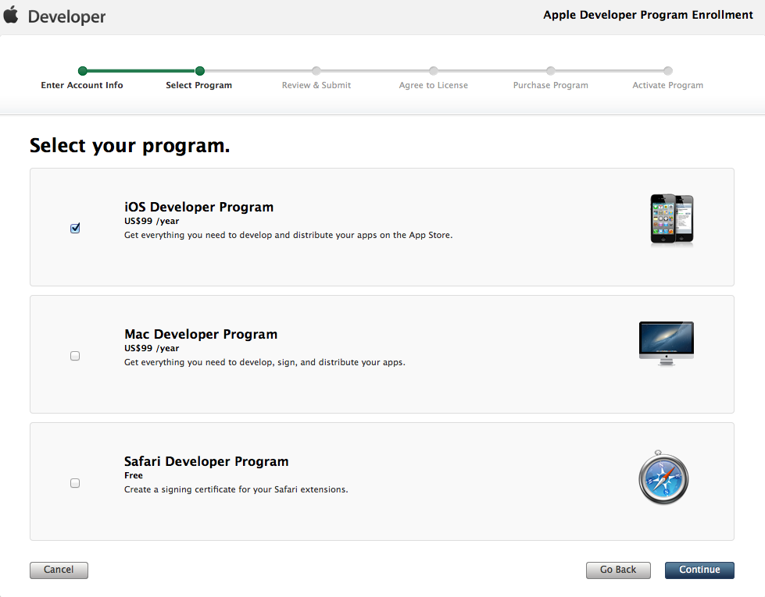

**10.** Next, you will choose how you want to enrol, individual or organization, view bellow what are the difference between them.

For organization you will need to get in touch with Dun & Bradstreet and request your company unique. <http://dnb.com.au/>

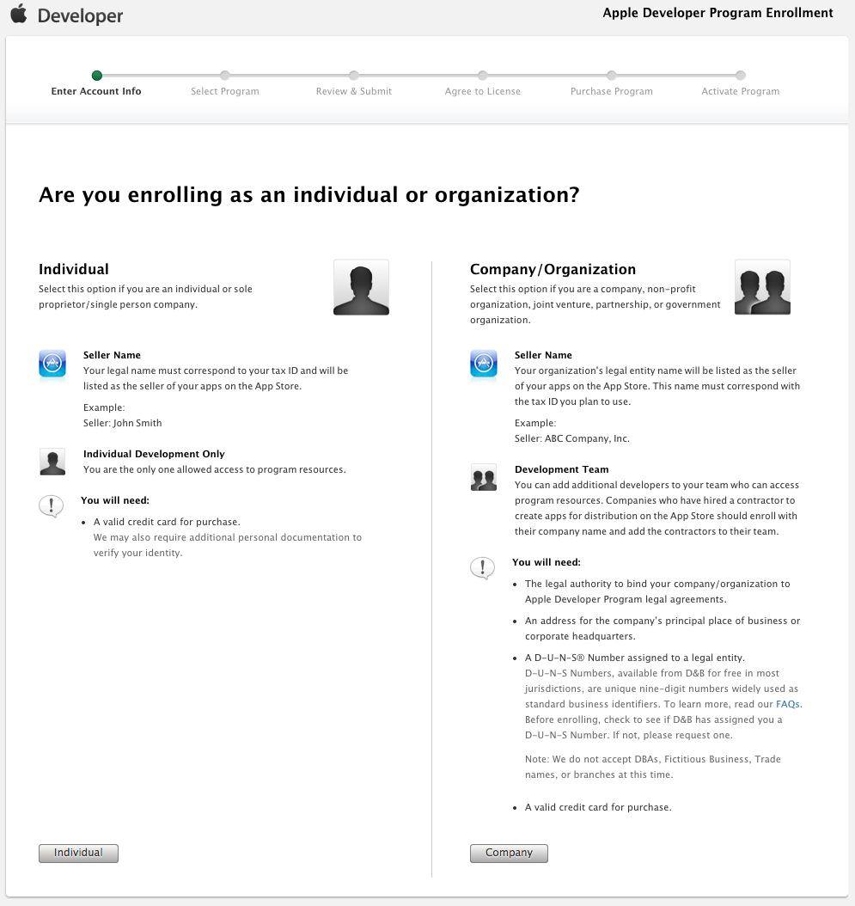

**11.** If you choose organization, you will be requested to enter some extra information about the organization, including the D.U.N.S number.

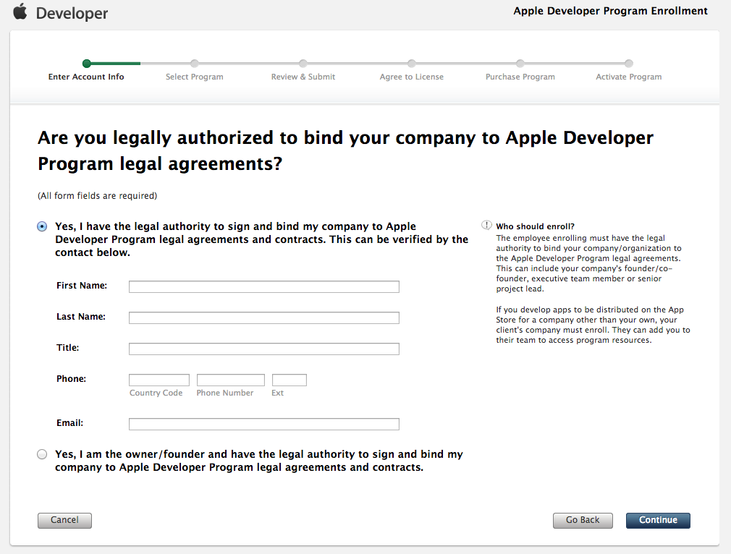

**12.** Review your enrolment info on the following page and click Continue. For organization enrolment, apple will restrict you on moving forward. This process can take up to 2 days to validate the organization information provided. In this mean time all you can do is wait for an email from apple confirming your enrolment.

**13.** Next, agree to the Program License Agreement and click Continue.

**14.** Finally, confirm your purchase by clicking Buy Now.

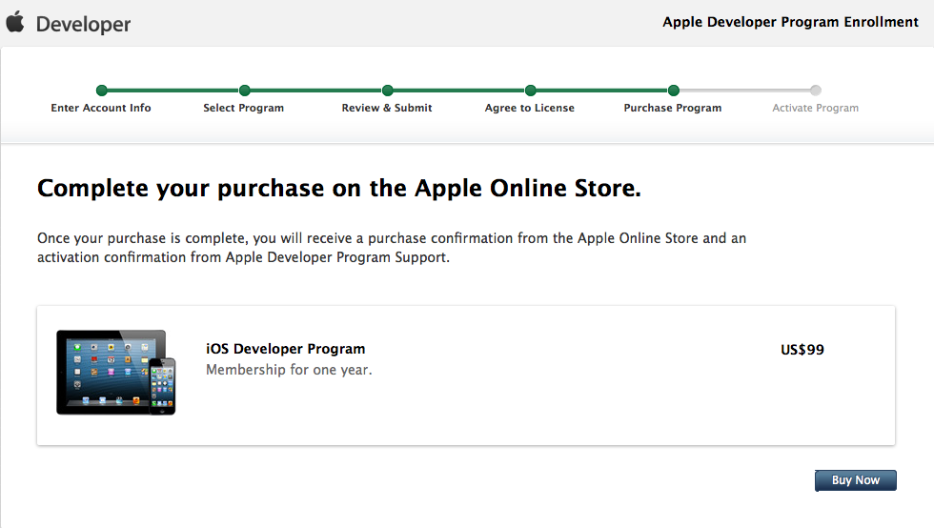

**15.** You should receive an email confirmation of your order with a link to verify your email address. Follow the instructions to confirm your account.

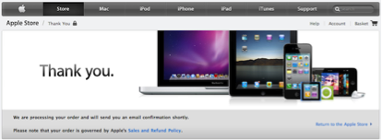

**16.** Please email us your Apple Developer login credentials so we can have them on file. We'll only access your account when necessary—to upload apps, renew push notification certificates, or resolve issues with apps. You'll provide us with your credentials each time you publish an app, and we recommend against changing your password frequently since it tacks on resolve time for issues.

Source:

https://developer.apple.com/

http://biznessapps.desk.com/customer/portal/articles/82347-apple-developer-overview-set-up